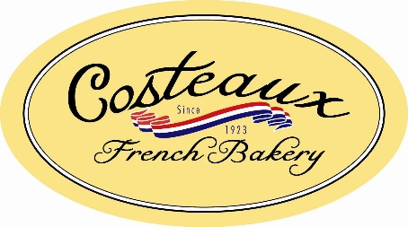

Costeaux French Bakery Announces the Opening of a New Location in Petaluma
Costeaux Expands into Southern Sonoma County Prior to 100th Year in Business

Healdsburg, Calif. – April 25, 2022 – Today, Costeaux French Bakery announces its retail expansion into Petaluma with a quaint café in the heart of town. Nearing the completion of county regulation approvals, Costeaux plans to offer pastries, breads, lunch and desserts to go by this summer. The new location, nestled in Hotel Petaluma, will be open seven days a week and feature full coffee service. The café will serve a goal of directly reaching more guests within Sonoma County.
“We are very fortunate to have a broad base of fans,” says Costeaux CEO Will Seppi. “For decades we have provided breads, biscotti and more to retailers throughout the area. Now we are excited to offer more for our guests from near and far.”
Costeaux was established in 1923 in Healdsburg, California and has since grown, under Seppi Family ownership, to distribute breads and more into markets, delis and hotels from San Francisco to Mendocino. When Will Seppi took over the management of the family business, he brought a vision of growth. The first retail footprint expansion was inside Big John’s Market and Costeaux On The Go next to the Sonoma County Airport followed soon after.
“Our weekend brunch guests were thrilled to have access to our pastries, breads, sandwiches and desserts at new locations closer to their home,” says Seppi. “These additional locations allowed our guests to incorporate our offerings into their daily rituals and family traditions.”
Costeaux On The Go in Santa Rosa proved to be a success and fostered the idea of vending machine access. In 2021, Costeaux began operating two vending machines accessible at the Sonoma County Airport to embrace innovation in fresh food availability. Travelers, local business staff and nearby families now have access to sandwiches, salads and more at any hour of the day.
Continuing to reach more Sonoma County residents, Seppi began to scout locations in Petaluma. Similar to the Santa Rosa location, this new Costeaux location would provide guests with pastries, sandwiches, salads, quiche, full coffee service and cakes.
“When we had the opportunity to walk through the Hotel Petaluma space, we knew it was a natural fit,” says Seppi. “Finding home in a business that was established in 1923, like Costeaux, was very special. Learning about the hotel’s status as the ‘go-to spot’ for Christmas cheer similar to our Healdsburg location was the icing on the cake.”
The additional Costeaux location is expected to open this June in Hotel Petaluma. The location will be accessible from Washington Street as well as through the hotel. The Washington Street entry is between Barber Cellars and the barbershop.
To learn more about the new location, follow Costeaux French Bakery on Facebook or Instagram. For additional press resources view the press kit at costeaux.com/accolades-press.
###
About Costeaux French Bakery
Family-owned since 1923, Costeaux French Bakery has built a longstanding reputation for specialty and artisan breads. The café in downtown Healdsburg offers seated breakfast, brunch and lunch options. Guests can visit one of the convenient store locations to select their own bread and desserts. Pickup and delivery are available for catered orders. A Costeaux retail bakery with coffee service is also available inside Big John’s Market in Healdsburg. Costeaux On The Go, a retail bakery, is available next to the Sonoma County Airport. Tia Maria by Costeaux, located in the Roseland neighborhood in Santa Rosa, features a large variety of Costeaux products, as well as traditional Hispanic baked goods.
Follow on Social Media
Instagram: @CosteauxFrenchBakery
Facebook: @Costeaux
Media Contact
Rose Jimenez
707-364-8663 | rjimenez@costeaux.com

